**PROJECT REPORT ON**

**ART GALLERY**

**Submitted to**



**Developed By**

**Lajvanti Sonaiya**

**MCA SEM – II 2021-22**

**Guided By**

Prof. Dhruvi Sidhpura

**Affiliated By:**

**NARANDAS JETHALAL SONECHA MANAGEMENT & TECHNICAL INSTITUTE**

**Approved by AICTE Affiliated to GTU**

At. Chanduvav, Tal. Veraval, Dist. Gir Somnath. (Gujarat)

**Certificate**

This is to certify that  _________________________________________________

A student of MCA Semester _________  Enrollment No.  ____________________

Has successfully carried out a project entitled  _____________________________

_______________________________________ towards fulfillment of the subject

______________________________ .

Date :

Signature of Guide Seal of the Institute Signature of HOD

* **PREFACE**

This report has been prepared for the “E-Commerce website”Project in which we developed the system for providing products to the customer on purchase using preferable technology Python framework Django.

Design of the software and controls is currently at the concept design level. This project during study is really precious one. It provides opportunity to meet and work with different Tools under guidance of our professor

The project has been developed and it implements, formal system engineering processes for documenting requirements, configuration control, interface control, product assurance, integration test, verification and validation.

**INDEX**

| **Sr.No.** | **Title** |
| --- | --- |
| 1 | Existing system |
| 2 | Need for the new system |
| 3 | Objective of the new system |
| 4 | Problem definition |
| 5 | Core components |
| 6 | Project profile |
| 7 | Assumption and Constraints |
| 8 | Advantages and Limitations of a Proposed System |
| 9 | Requirement and Determinations |
| 10 | Targeted Users |
| 11 | Use case diagram |
| 12 | Class diagram |
| 13 | Interaction diagram |
| 14 | Activity Diagram |
| 15 | Data dictionary |
| 16 | Coding and screenshots |
| 17 | Proposed Enhancements |
| 18 | Conclusion |
| 19 | Bibliography |

*\*\*INTRODUCTION\*\**

1. EXISTING SYSTEM

You can get several benefits with the **learning objectives of e-commerce**, like cost reduction, growth, gaining a popular brand image, and much more. Some of the most popular and primary objectives of E-Commerce are here:

### Financial benefits

The primary aim of every business is to focus on cost reduction, and E-Commerce helps them do the same effectively. The automatic process of e-commerce helps to reduce the cost of management. The proper use of technology, Digital Marketing, can help you gain more customers without investing much.

### Personal connect with clients

When businesses use e-commerce as a primary technique, they can easily grab achievement. When there is direct communication between the company and customers, the relationship boosts up. Eventually, companies can connect with more customers and result in increased growth.

### Simplification of Customer management

Customers are the core element of any business whether it is b2b or b2c, and making a stable relationship with your existing customers is significant. E-commerce helps you sustain your customers for a longer period. Social media networking is the most used platforms, and with these, you can grab your customers’ attention. With E-commerce, you can establish a brand name using social media networks.

### Reliable business strategy

According to [Google](https://www.google.co.in/), almost 60% of people prefer searching for things that they want to buy or opt for services on the internet. They check out the top 3 search results for their query. And, if you do not appear in that top 3 list, you might lose customers. So, E-commerce will help you to establish a strong brand presence so that you can capture new customers.

### Competence of Services

By opting for the online E-commerce platform, you can boost up your efficiency. Opting for E-commerce not only increases your sales but also helps as a cost-effective method. With E-commerce, you can reduce your warehousing cost. It eventually helps you save more funds at your disposal. You can also reduce delivery time with E-commerce and make your customers happy.

2. NEED FOR THE NEW SYSTEM

#### (a) Computer System and basic hardware:

Availability of the computer system is the first requirement of e-commerce; because the basis of e-commerce is the Internet and the computer is the medium of transaction. The computer can be linked with the Internet. Sound Computer System is the basic mandatory requirement for the business transactions under e-commerce.

#### (b) Stable Internet Connection:

For implementing the e-commerce transactions, Internet connection is one of the must We can get this facility of Internet connection, through Service Provider companies. The second most important requirement is having a smooth Browser to access the site.

#### (c) Basic Technical knowledge:

The business enterprise must have technically qualified people who are capable of working with computer networks and the Internet without difficulty.

#### (d) Payment system:

The business enterprise should have a sound and secure system of receiving payment for the financial transactions. The enterprise must make arrangements with financial institutes (generally Banks) to facilitate receipts and payments electronically.

#### (e) A good Website:

To communicate effectively with customers and others, the business enterprise must develop a comprehensive website. The information must be detailed and hyperlinked with suitable supporting pictures etc. (Hyperlink is a place in an electronic document on a computer that is linked to another electronic document).

#### (f) Operational Telecommunication System:

For a successful implementation of e-commerce, an effective telecommunication system is necessary. If telephone lines are getting frequently disconnected; e-commerce is not successful.

3. OBJECTIVE OF THE NEW SYSTEM

#### 1. INTRODUCTION

This section includes the overall view of the project i.e. the basic problem definition and the general overview of the problem which describes the problem in simplest terms. It also specifies the software used and the proposed solution strategy.

#### 2. SOFTWARE REQUIREMENT SPECIFICATION

This section includes the Software and hardware requirements for the smooth running of the application.

#### 3. DESIGN & PLANNING

This section consists of the Software Development Life Cycle model. It also contains technical diagrams like the Data Flow Diagram and the Entity Relationship diagram.

#### 4. IMPLEMENTAION DETAILS

This section describes the different technologies used for the entire development process of the Front-end as well as the Back-end development of the application.

#### 5. RESULT

This section has screenshots of all the implementation i.e. user interface and their description.

#### 6. SUMMARY AND CONCLUSION

This section has screenshots of all the implementation i.e. user interface and their description.

4. PROBLEM DEFINITION

E-commerce provides an easy way to sell products to a large customer base. However, there is a lot of competition among multiple e-commerce sites. When users land on an e-commerce site, they expect to find what they are looking for quickly and easily. Also, users are not sure about the brands or the actual products they want to purchase. They have a very broad idea about what they want to buy. Many customers nowadays search for their products on Google rather than visiting specific e-commerce sites. They believe that Google will take them to the e-commerce sites that have their product.

The purpose of any e-commerce website is to help customers narrow down their broad ideas and enable them to finalize the products they want to purchase. For example, suppose a customer is interested in purchasing a mobile. His or her search for a mobile should list mobile brands, operating systems on mobiles, screen size of mobiles, and all other features as facets. As the customer selects more and more features or options from the facets provided, the search narrows down to a small list of mobiles that suit his or her choice. If the list is small enough and the customer likes one of the mobiles listed, he or she will make the purchase.

The challenge is also that each category will have a different set of facets to be displayed. For example, searching for books should display their format, as in paperback or hardcover, author name, book series, language, and other facets related to books. These facts are different for paintings that we discussed earlier. Similarly, each category will have different facets and it needs to be designed properly so that customers can narrow down to their preferred products, irrespective of the category they are looking into.

The takeaway from this is that categorization and feature listing of products should be taken care of. Misrepresentation of features can lead to incorrect search results. Another takeaway is that we need to provide multiple facets in the search results. For example, while displaying the list of all mobiles, we need to provide facets for a brand. Once a brand is selected, another set of facets for operating systems, network, and mobile phone features has to be provided. As more and more facets are selected, we still need to show facets within the remaining products.

5. CORE COMPONENTS

#### User interface app components

This is a reference to the web pages that have a role that is related to the display, settings and configurations. It is related the interface/experience, rather than the development, and consequently it deals with display dashboards, configuration settings, notifications, and logs etc.

#### Structural components

The structural components of a web application basically refer to the functionality of the web application with which a user interacts, the control and the database storage.

In other words, it has got more to do with the structural aspects of the architecture, as the name suggests. This basically comprises (1) The web browser or client, (2) The web application server and

(3) The database server.

The web browser or client permits the users to interact with the functions of the web apps and is generally developed using HTML, CSS, JavaScript,bootstrape,jango.

#### HTML:-

* + - * HTML stands for Hyper Text Markup Language that is used to develop web pages.
      * **Hypertext** refers to the way in which Web pages (HTML documents) are linked together. Thus, the link available on a webpage is called Hypertext.
      * As its name suggests, HTML is a **Markup Language** which means you use HTML to simply "markup" a text document with tags that tell a Web browser how to structure it to display.
      * HTML is not a programming Language like C, C++ and JAVA etc…
      * It is cross platform markup language that is design to be flexible enough to display text and other elements like graphical on a variety of views.
      * The HTML document consists of special tags that are embedded in an ASCH document.
      * Web browser like Internet Explorer, Netscape Navigator etc... Interprets these tags.

#### 

#### CSS:-

If Cascading Style Sheets can be a bit intimidating at first glance, especially if you are new to webpage coding It might be best to avoid getting into Style until you have done a few pages and are comfortable handling basic html. Style sheet coding offers:

* + - * An impressive array of features not available in standard HTML4. The use of style permits you to really fine tune the appearance of your pages. And, it is not difficult to learn.
      * In addition to offering many options not available in standard html, style can save you time, increase accuracy, and improve uniformity of appearance throughout your web pages. Style Sheets, whether External, Internal or Inline, give you expanded design capabilities with flexibility. You can combine the best features of HTML4 with those of Style, and produce a better webpage.
      * For me, the biggest plus factor for style sheets is the time saved in not having to constantly type formatting statements for headlines and paragraphs. The time savings is not only in the keystrokes that are eliminated, but in the extreme accuracy obtained I can't make types in all that stuff I don't type and then have to go back and make corrections.
      * This is what my basic style sheet for this website looks like.
      * In effect, that one-line link statement tells the browser to go get the style.css file and make use of it during the execution of this .html file you are now viewing.

#### Python :-

* Python is a simple, general purpose, high level, and object-oriented programming language.
* Python is an interpreted scripting language also. *Guido Van Rossum* is known as the founder of Python programming.
* Our Python tutorial includes all topics of Python Programming such as installation, control statements, [Strings](https://www.javatpoint.com/python-strings), [Lists](https://www.javatpoint.com/python-lists), [Tuples](https://www.javatpoint.com/python-tuples), [Dictionary](https://www.javatpoint.com/python-dictionary), [Modules](https://www.javatpoint.com/python-modules), [Exceptions](https://www.javatpoint.com/python-exception-handling), Date and Time, File I/O, Programs, etc. There are also given Python interview questions to help you better understand Python Programming.
* **Python** is a general purpose, dynamic, [high-level](https://www.javatpoint.com/classification-of-programming-languages), and interpreted programming language. It supports Object Oriented programming approach to develop applications. It is simple and easy to learn and provides lots of high-level data structures.
* Python is *easy to learn* yet powerful and versatile scripting language, which makes it attractive for Application Development.
* Python's syntax and *dynamic typing* with its interpreted nature make it an ideal language for scripting and rapid application development.
* Python supports *multiple programming patterns*, including object-oriented, imperative, and functional or procedural programming styles.
* Python is not intended to work in a particular area, such as web programming. That is why it is known as *multipurpose* programming language because it can be used with web, enterprise, 3D CAD, etc.
* We don't need to use data types to declare variable because it is *dynamically typed* so we can write a=10 to assign an integer value in an integer variable.
* Python makes the development and debugging *fast* because there is no compilation step included in Python development, and edit-test-debug cycle is very fast.

#### Django (Framework) :-

Django is a Web Application Framework which is used to develop web applications.

Our Django Tutorial includes all topics of Django such as introduction, features, installation, environment setup, admin interface, cookie, form validation, Model, Template Engine, Migration, MVT etc. All the topics are explained in detail so that reader can get enought knowledge of Django.

Django is a web application framework written in Python programming language. It is based on MVT (Model View Template) design pattern. The Django is very demanding due to its rapid development feature. It takes less time to build application after collecting client requirement.

This framework uses a famous tag line:**The web framework for perfectionists with deadlines.**

By using Django, we can build web applications in very less time. Django is designed in such a manner that it handles much of configure things automatically, so we can focus on application development only.

6. PROJECT PROFILE

| Project Profile | * Art Gallery Website |
| --- | --- |
| Project Category | * Web Development |
| Front End | * Python (Django) |
| Back End | * SQLite |
| Browser | * Google Chrome, Mozilla Firefox, Microsoft Edge |
| Operating System | * Windows |
| Documentation | * Microsoft word 2010 or Higher |
| Developed By | * Lajvanti , Kajal and Upasana |
| Project Guide | * Prof. Dhruvi Sidhpura |
| Submitted To | * Narandas Jethalal Sonecha Management and Technical Institute |
| University | * Gujarat Technological University (GTU) |

7. ASSUMPTIONS AND CONSTRAINTS

* ***Assumptions***

**You are established**  
you see it all the time, businesses want to tell the world “their story” and how they operate, how they are wholesome, trust worthy and what they believe in. Adding credibility is one thing, but for the most part your customers don’t care that you are the biggest supplier of X product, they just want to know what you and your product can do for them.

**People are aware about your Product**  
another common mistake is forgetting that you are an expert, but your customers may not be. Giving item details is great, but most customers don’t know what DDR2 Ram is, they just want to know that they will be able to check emails and watch TV online.

**They are clear about their needs**  
Some customers know what they want & how much it should cost and if they find you first you’ll make an easy sale. But most customers don’t really know what they want, they have questions and they need reassurance. Your website isn’t just a catalogue, sometimes you need to actually help your customers to make the right buying decision.

**Time required for surfing is available**   
This fits nicely with the last 3 points. You know the market inside out, but your customers probably don’t and they don’t have time to check every single option. If you are in the right place and give them the feelings, you don’t always have to be the best option.

**You will be searched**   
As a digital marketing agency we see this assumption cost a lot of small businesses a lot of money. There is an assumption online that all you need is a website to start a business. There is no “Build it and they will come”, you need a marketing plan if you want customers to actually find you out of the many other websites competing for their attention.

**Feedback will be received**  
You know of course that you need to keep your customers happy to build a successful business, but don’t fall into the trap of assuming that they will give you feedback without being prompted. If you are doing something wrong, most customers won’t complain, they will just go elsewhere. Ask your customers how they really feel (positive or negative).

**Mouth publicity will be made**  
Word of mouth is a powerful marketing tool for small businesses and if you get the formula right you can do very well, but don’t assume that excellent service is enough to get the ball rolling. Customers are generally lazy, they won’t go and market your business without being prompted, so take the time to ask them to spread the word, the worst they can do is decline.

* ***Constraints***





The state of being checked, restricted or compiled to avoid or perform some action is called constraints

In other words we can say constraints are a limiting factor that affects the execution of a project, program, portfolio or process.

It means that a project team is always working under some limitations and restrictions. The team does not have complete freedom to perform their actions. Some of these limitations are imposed by the project stakeholders but many others are intrinsically present in the environment.

***Few Points of Constraints in Project***

* Scope - It includes the work as defined in the contract.
* Schedule – It includes the deadlines imposed by the customer
* Budget – It includes the funding limits imposed by the sponsor.
* Quality – It includes organization or quality standards like CMMI.
* Resources – It includes unavailability of skilled & competent people.
* Risks – It includes threats and opportunities

8. ADVANTAGES AND DISADVANTAGES OF A

PROPOSED SYSTEM

* ***PROPOSED SYSTEM***

The development of this new system contains the following activities, which try to automate the entire process keeping in the view of database integration approach.

* The system makes the overall project management much easier and flexible
* The user information can be stored in centralized database which can be maintained by the system
* This can give the good security for user information because data is not in client machine
* Authentication is provided for this application only registered users can access
* There is no risk of data management at any level while the project development is under process
* The automated system will provide to the customers for reliable services
* ***ADVANTAGES OF PROPOSED SYSTEM***
* User friendliness is provided in the application with various controls provided by system rich user interface
* It can be accessed over the internet
* The speed and accuracy of this system will improve more and more
* Better aesthetics, Terminal comfort
* Better aesthetics, permanent materials, fast constructions time, best quality control
* Less maintenance, Low initial cost, Materials are available
* Better aesthetics, Durable material, Terminal comfort, Acoustic insulation
* ***DISADVANTAGES OF PROPOSED SYSTEM***
* Require skilled labor, High initial cost of material, Long construction time, Frequent maintenance
* Transportation arrangement, Thermal heat gain
* Large material wastage, Large construction time
* Transportation arrangement

REQUIREMENT DETERMINATION AND ANALYSIS

9. REQUIREMENT DETERMINATION

* ***WHAT IS REQUIREMENT DETERMINATION?***

A Requirement is a vital feature of a new system which may include processing or capturing of data, controlling the activities of business, producing information and supporting the management.

Requirements determination involves studying the existing system and gathering details to find out what are the requirements, how it works, and where improvements should be made

* ***Major Activities in Requirement Determination***

***Requirement Anticipation***

* It predicts the characteristics of system based on previous experience which include certain problems or features and requirements for a new system.
* It can lead to analysis of areas that would otherwise go unnoticed by inexperienced analyst. But if shortcuts are taken and bias is introduced in conducting the investigation, then requirement anticipation can be half baked.

***Requirement Investigation***

* It is studying the current system and documenting its features for further analysis
* It is at the heart of system analysis where analyst documenting and describing system features using fact-finding techniques, prototyping, and computer assisted tools.

***Requirement Specifications***

* It includes the analysis of data which determine the requirement specification, description of features for new system, and specifying what information requirements will be provided.
* It includes analysis of factual data, identification of essential requirements, and selection of requirement- fulfillment strategies

**Feasibility Study**

Feasibility study can be considered as preliminary investigation that helps the management to take decision about whether study of system should be feasible for development or not.

* It identifies the possibility of improving an existing system, developing a new system, and produce refined estimates for further development of system.
* It is used to obtain the outline of the problem and decide whether feasible or appropriate solution exists or not.
* The main objective of a feasibility study is to acquire problem scope instead of solving the problem.

The following steps are to be followed while performing feasibility analysis –

* From a project team and appoint a project leader
* Develop system flowcharts
* Identify the deficiencies of current system and set goals
* Enumerate the alternative solution or potential candidate system to meet goals.
* Determine the feasibility of each alternative such as technical feasibility, operational feasibility, etc.
* Weight the performance and cost effectiveness of each candidate system
* Rank the other alternatives and select the best candidate system.
* Prepare a system proposal of final project directive to management for approval.



* ***TECHNICAL FEASIBILITY***
* It investigates the technical feasibility of each implementation alternative.
* It analyzes and determines whether the solution can be supported by existing technology or not.
* The analyst determines whether current technical resources be upgraded or added it that fulfill the new requirements.
* It ensures that the candidate system provides appropriate responses to what extent it can support the technical enhancement
* ***OPERATIONAL FEASIBILITY***
* It determines whether the system is operating effectively once it is developed and implemented.
* It ensures that the management should support the proposed system and its working feasible in the current organizational environment
* It analyzes whether the users will be affected and they accept the modified or new business methods that affect the possible system benefits
* It also ensures that the computer resources and network architecture of candidate system are workable.
* ***ECONOMIC FEASIBILITY***
* It is evaluating the effectiveness of candidate system by using cost/benefit analysis method.
* It demonstrates the net benefits from the candidate system in term of benefits and costs to the organization.
* The main aim of economic feasibility analysis is to estimate the economic requirements of candidate system before investments funds are committed to proposal
* It prefers the alternative which will maximize the net worth of organization by earliest and highest return of funds along with lowest level of risk involved in developing the candidate system.
* ***BEHAVIORAL FEASIBILITY***
* It evaluates and estimates the user attitude or behavior towards the development of new system.
* It helps in determining if the system requires special effort to educate, retrain, transfer, and changes in employees job status on new ways of conducting business
* ***SCHEDULE FEASIBILITY***
* It ensures that the project should be completed within given time constraint or schedule.
* It also verifies and validates whether the deadlines of project are reasonable or not.

10. TARGETED USERS

An ecommerce target market is a group of people or institutions that are most likely to share the same shopping interests and might be willing to buy a company’s products and services.

As these folks are the most potential prospects for an ecommerce store that’s dealing in its respective niche, it makes more sense for that ecommerce store to focus on these groups in terms of marketing and keeping them hooked with their online store.

* ***Segments of Targeted User***
* **Home Collectors**
* **Interior designers**
* **Investors**
* **People with an immediate need for art**
* **Art lovers**

*SYSTEM DESIGN*

11. USE CASE DIAGRAM





12. CLASS DIAGRAM





13. INTERACTION DIAGRAM





14. ACTIVITY DIAGRAM (LOGIN)





14. ACTIVITY DIAGRAM (Painting Buying System)



SDLC MODEL















15. DATA DICTIONARY

***Picture Table:-***

| ***FieldType*** | ***DataType*** |
| --- | --- |
| title | CharField |
| price | FloatField |
| desc | TextField |
| category | CharField |
| image | ImageField |

***Cart Table:-***

| ***FieldType*** | ***DataType*** |
| --- | --- |
| user | CharField(FK) |
| picture | CharField(FK) |
| quantity | PositiveIntegerField |

***Customer Table:-***

| ***FieldType*** | ***DataType*** |
| --- | --- |
| user | CharField(FK) |
| name | CharField |
| city | CharField |
| state | CharField |
| zipcode | IntegerField |
| address | CharField |

***OrderPlaced Table:-***

| ***FieldType*** | ***DataType*** |
| --- | --- |
| user | CharField(FK) |
| customer | CharField(FK) |
| pictures | CharField(FK) |
| quantity | PositiveIntegerField |
| ordered_date | DateTimeField |
| status | CharField |

***Feedback Table:***

| ***FieldType*** | ***DataType*** |
| --- | --- |
| name | CharField |
| email | CharField |
| subject | CharField |
| message | TextField |

DEVELOPMENT

16. CODING STANDARD AND SCREENSHOTS

**Master.html**

<!DOCTYPE html>

<html lang="en">

<head>

<meta charset="utf-8">

<meta name="viewport" content="width=device-width, initial-scale=1, shrink-to-fit=no">

<meta name="description" content="">

<meta name="author" content="">

<link href="https://fonts.googleapis.com/css?family=Poppins:100,200,300,400,500,600,700,800,900&display=swap" rel="stylesheet">

<title>Art Gallery </title>

<!-- Bootstrap core CSS -->

<link href="/static/vendor/bootstrap/css/bootstrap.min.css" rel="stylesheet">

<!--

TemplateMo 546 Sixteen Clothing

https://templatemo.com/tm-546-sixteen-clothing

-->

<!-- Additional CSS Files -->

<link rel="stylesheet" href="/static/assets/css/fontawesome.css">

<link rel="stylesheet" href="/static/assets/css/templatemo-sixteen.css">

<link rel="stylesheet" href="/static/assets/css/owl.css">

</head>

<body>

<!-- ***** Preloader Start ***** -->

<div id="preloader">

<div class="jumper">

<div></div>

<div></div>

<div></div>

</div>

</div>

<!-- ***** Preloader End ***** -->

<!-- Header -->

<header class="">

<nav class="navbar navbar-expand-lg">

<div class="container">

<a class="navbar-brand" href="index"><h2>Art <em> Gallery</em></h2></a>

<button class="navbar-toggler" type="button" data-toggle="collapse" data-target="#navbarResponsive" aria-controls="navbarResponsive" aria-expanded="false" aria-label="Toggle navigation">

<span class="navbar-toggler-icon"></span>

</button>

<div class="collapse navbar-collapse" id="navbarResponsive">

<ul class="navbar-nav ml-auto">

{% if user.is_authenticated %}

<li class="nav-item">

<a class="nav-link" href=#>Hello, {{user.username}}</a>

</li>

<li class="nav-item">

<a class="nav-link" href="{% url 'index'%} ">Home

</a>

</li>

<li class="nav-item">

<a class="nav-link" href="{% url 'paintingname' 'none'%} ">our Painting</a>

</li>

<li class="nav-item">

<a class="nav-link" href="{% url 'ViewCart'%} ">Cart</a>

</li>

<li class="nav-item">

<a class="nav-link" href="{% url 'orderdone'%} ">My Order</a>

</li>

<li class="nav-item">

<a class="nav-link" href="{% url 'feedback'%} ">FeedBack</a>

</li>

<li class="nav-item">

<a class="nav-link" href="{% url 'logout'%} ">Log Out</a>

</li>

{%else%}

<li class="nav-item">

<a class="nav-link" href="{% url 'index'%}">Home

</a>

</li>

<li class="nav-item">

<a class="nav-link" href="{% url 'paintingname' 'none'%} ">our Painting</a>

</li>

<li class="nav-item">

<a class="nav-link" href="{% url 'register'%}">Register</a>

</li>

<li class="nav-item">

<a class="nav-link" href="{% url 'login'%}">login</a>

</li>

<li class="nav-item">

<a class="nav-link" href="{% url 'feedback'%} ">FeedBack</a>

</li>

{%endif%}

</ul>

</div>

</div>

</nav>

</header>

<!-- Bootstrap core JavaScript -->

<script src="/static/vendor/jquery/jquery.min.js"></script>

<script src="/static/vendor/bootstrap/js/bootstrap.bundle.min.js"></script>

<!-- Additional Scripts -->

<script src="/static/assets/js/custom.js"></script>

<script src="/static/assets/js/owl.js"></script>

<script src="/static/assets/js/slick.js"></script>

<script src="/static/assets/js/isotope.js"></script>

<script src="/static/assets/js/accordions.js"></script>

<script language = "text/Javascript">

cleared[0] = cleared[1] = cleared[2] = 0; //set a cleared flag for each field

function clearField(t){ //declaring the array outside of the

if(! cleared[t.id]){ // function makes it static and global

cleared[t.id] = 1; // you could use true and false, but that's more typing

t.value=''; // with more chance of typos

t.style.color='#fff';

}

}

</script>

</body>

</html>

{% block 'body'%}

{% endblock 'body'%}

**Index.html**

{% extends 'master.html' %}

{% block 'body'%}

<body style="background-color: #d2c9ff;" >

<!-- Banner Starts Here -->

<div class="banner header-text">

<div class="owl-banner owl-carousel">

<div class="banner-item-01">

<div class="text-content">

</div>

</div>

<div class="banner-item-02">

<div class="text-content">

</div>

</div>

<div class="banner-item-03">

<div class="text-content">

</div>

</div>

</div>

</div>

<!-- Banner Ends Here -->

<div class="latest-products">

<div class="container">

<div class="row">

<div class="col-md-12">

<div class="section-heading">

<h2>Painting</h2>

<a href="{% url 'paintingname' 'none'%}">view all products <i class="fa fa-angle-right"></i></a>

</div>

</div>

{% for i in all %}

<div class="col-md-4">

<div class="product-item">

<a href="{% url 'imagedetail' i.id %}"><img src={{i.image.url}} alt="" height="300" ></a>

<div class="down-content">

<h2>{{i.title}}</h2>

<h4>RS. {{i.price}}</h4>

</div>

</div>

</div>

{% endfor %}

</div>

</div>

</div>

<!-- about -->

<div class="best-features">

<div class="container">

<div class="row">

<div class="col-md-12">

<div class="section-heading">

<h2>About us </h2>

</div>

</div>

<div class="col-md-6">

<div class="left-content">

<br><br>

<h5>Lajvanti Sonaiya </h5>

<h4>email:lssonaiya2000@gmail.com</h4><br>

<h5>Kajal Serlarka </h5>

<h4>email:kajal123@gmail.com</h4><br>

<h5>Upashana Joshi</h5>

<h4>email:upashna1718@gmail.com</h4>

</div>

</div>

<div class="col-md-6">

<div class="right-image">

<img src="/static/assets/images/feature-image.jpg" alt="">

</div>

</div>

</div>

</div>

</div>

</body>

<!-- end about -->

{% endblock 'body'%}

**register.html**

**{% extends 'master.html' %}**

**{%block 'body'%}**

**<html>**

**<body style="background-color: #d2c9ff;" >**

**<br><br><br><br><br><br>**

**<h1 align="center"><u><b>Register</b></u></h1>**

**<br><br>**

**<form action="" method="POST" align="center" name="form1">**

**<table align="center">**

**{% csrf_token %}**

**<tr>**

**<td>User Name:<br><br></td>**

**<td><input type="text" name='username'autocomplete="off" required /><br><br></td>**

**</tr>**

**<tr>**

**<td>E-mail :<br><br></td>**

**<td><input type="email" name='email' autocomplete="off" required /><br><br></td>**

**</tr>**

**<tr>**

**<td>Password:<br><br></td>**

**<td><input type="password" name='pass' autocomplete="off" required /><br><br></td>**

**</tr>**

**</table>**

**<input type="submit" value='submit' /><br><br>**

**<a href="{% url 'login'%}">Already register?</a>**

**</form>**

**</body>**

**</html>**

**{%endblock 'body'%}**

**login.html**

**{% extends 'master.html' %}**

**{%block 'body'%}**

**<body style="background-color: #d2c9ff;">**

**<br><br><br><br><br><br>**

**<h1 align="center"><u><b>Login</b></u></h1>**

**<br><br>**

**<form action="" method="POST" align="center" name="form1">**

**<table align="center">**

**{% csrf_token %}**

**<tr>**

**<td>User Name: <br><br></td>**

**<td><input type="text" name='username' required autocomplete="off"/><br><br></td>**

**</tr>**

**<tr>**

**<td>Password: <br><br></td>**

**<td><input type="password" name='pass' required autocomplete="off" /><br><br></td>**

**</tr>**

**</table>**

**<input type="submit" value='submit'/><br><br>**

**<a href="{% url 'register'%}">New User Register First?</a>**

**{% if messages %}**

**{% for message in messages %}**

**<p {% if message.level == DEFAULT_MESSAGE_LEVELS.ERROR %} style="color: red; " {% else %} style="color: green"; {% endif %}> {{ message }} </p>**

**{% endfor %}**

**{% endif %}**

**</form>**

**</body>**

**</html>**

**{%endblock 'body'%}**

**painting.html**

{% extends 'master.html'%}

{% block 'body'%}

<body style="background-color: #d2c9ff;" ></body>

<br><br>

<div class="products-heading header-text">

<div class="container">

<div class="row">

<div class="col-md-12">

</div>

</div>

</div>

</div>

<div class="products">

<div class="container">

<div class="row">

<div class="col-md-12">

<div class="filters">

<ul>

<a href="{% url 'paintingname' 'none' %}"><li data-filter="*">All Painting</li></a>

<a href="{% url 'paintingname' 'oil' %}"><li data-filter=".des">Oil Painting</li></a>

<a href="{% url 'paintingname' 'water' %}"> <li data-filter=".dev">Watercolor Painting</li></a>

<a href="{% url 'paintingname' 'spay' %}"><li data-filter=".gra">Spay Painting</li></a>

</ul>

</div>

</div>

{% for i in paint %}

<div class="col-md-4">

<div class="product-item">

<a href="{% url 'imagedetail' i.id %}"><img src={{i.image.url}} alt="" height="300" width="4 00"></a>

<div class="down-content">

<h2>{{i.title}}</h2>

<h4>RS.{{i.price}}</h4>

</div>

</div>

</div>

{% endfor %}

</div>

</div>

</div>

</body>

{% endblock 'body'%}

**pictures_detail.html**

**{% extends 'master.html' %}**

**{%block 'body'%}**

**<html>**

**<head>**

**<link rel="stylesheet" type="text/css" href="/static/assets/css/detail.css"/>**

**</head>**

**<body style="background-color: #d2c9ff;">**

**<br><br><br><br><br><br>**

**<center><h1><u><b>Painting Detail Page</b></u></h1></center>**

**<br>**

**<div class="main">**

**<div class="image">**

**<img src={{img.image.url}} />**

**</div>**

**<div class="desc">**

**<h1>{{img.title}}</h1>**

**<br>**

**<h3>RS.{{img.price}}</h3>**

**<br>**

**<h4>{{img.desc}}</h4>**

**<br>**

**{% if already_cart is True %}**

**<a href="{% url 'AddToCart' 0 %}" class="cart">View cart</a>**

**{%else%}**

**<div class="button">**

**<form action="{% url 'AddToCart' img.id %}" method="POST" >**

**{% csrf_token %}**

**<input type="submit" value="Add to cart" class="cart" />**

**{% endif%}**

**</form>**

**</div>**

**</div>**

**</div>**

**</body>**

**</html>**

**{%endblock 'body'%}**

**cart.html**

**{% extends 'master.html'%}**

**{% load static%}**

**{% block 'body'%}**

**<html>**

**<body>**

**<section class="h-100 h-custom" style="background-color: #d2c9ff;">**

**<div class="container py-5 h-100">**

**<div class="row d-flex justify-content-center align-items-center h-100">**

**<div class="col-12">**

**<div class="card card-registration card-registration-2" style="border-radius: 15px;">**

**<div class="card-body p-0">**

**<div class="row g-0">**

**<div class="col-lg-8">**

**<div class="p-5">**

**<div class="d-flex justify-content-between align-items-center mb-5">**

**<h1 class="fw-bold mb-0 text-black">Shopping Cart</h1>**

**</div>**

**{%for cart in carts%}**

**<hr class="my-4">**

**<div class="row mb-4 d-flex justify-content-between align-items-center">**

**<div class="col-md-2 col-lg-2 col-xl-2">**

**<img**

**src="{{cart.picture.image.url}}"**

**class="img-fluid rounded-3" alt="Cotton T-shirt">**

**</div>**

**<div class="col-md-3 col-lg-3 col-xl-3">**

**<h6 class="text-black mb-0">{{cart.picture.title}}</h6>**

**</div>**

**<div class="col-md-3 col-lg-3 col-xl-2 d-flex">**

**<!-- <input type=button class="plusCart" value="-"/> -->**

**<a href="{% url 'decrement' cart.id %}"><button>-</button></a>**

**<span>&nbsp;&nbsp;&nbsp;{{cart.quantity}}&nbsp;&nbsp;&nbsp;</span>**

**<!--<a class="btn btn-link px-2" value="+"></a>-->**

**<a href="{% url 'increment' cart.id %}"><button>+</button></a>**

**</div>**

**<div class="col-md-3 col-lg-2 col-xl-2 offset-lg-1">**

**<h6 class="mb-0">RS.{{cart.picture.price}}</h6>**

**</div>**

**<div class="col-md-2 col-lg-2 col-xl-2">**

**<a href="{% url 'remove' cart.id%}"><button type="button" class="btn btn-danger">Remove</button></a>**

**</div>**

**</div>**

**{%endfor%}**

**<hr class="my-4">**

**<div class="pt-5">**

**<h6 class="mb-0"><a href="#!" class="text-body">**

**<i class="fas fa-long-arrow-alt-left me-2"></i><a href="{% url 'paintingname' 'none'%} ">Back to shop</a></a></h6>**

**</div>**

**</div>**

**</div>**

**<div class="col-lg-4 bg-grey">**

**<div class="p-5">**

**<h3 class="fw-bold mb-5 mt-2 pt-1">Summary</h3>**

**<hr class="my-4">**

**<div class="d-flex justify-content-between mb-4">**

**<h5 class="text-uppercase">items </h5>**

**<h5>{{item}}</h5>**

**</div>**

**<div class="d-flex justify-content-between mb-4">**

**<h5 class="text-uppercase">Amount</h5>**

**<h5>{{amount}}</h5>**

**</div>**

**<div class="d-flex justify-content-between mb-4">**

**<h5 class="text-uppercase">Shipping</h5>**

**<h5>RS.70</h5>**

**</div>**

**<hr class="my-4">**

**<div class="d-flex justify-content-between mb-5">**

**<h5 class="text-uppercase">Total price</h5>**

**<h5>{{total}} </h5>**

**</div>**

**<a href="{% url 'customerdetail' %}"><button type="button" class="btn btn-dark btn-block btn-lg data-mdb-ripple-color=dark">Continue</button></a>**

**</div>**

**</div>**

**</div>**

**</div>**

**</div>**

**</div>**

**</div>**

**</div>**

**</section>**

**</body>**

**</html>**

**{% endblock 'body'%}**

**customer.html**

**{% extends 'master.html' %}**

**{%block 'body'%}**

**<html>**

**<head>**

**</head>**

**<body style="background-color: #d2c9ff;">**

**<br><br><br><br><br><br>**

**<h1 align="center"><u><b>Add Your Details</b></u></h1>**

**<br><br>**

**<form method="POST" align="center" name="form1" action="{% url 'checkout'%}">**

**<table align="center" >**

**{% csrf_token %}**

**<tr>**

**<td>Name:<br><br></td>**

**<td>{{form.name}}<br><br></td>**

**</tr>**

**<tr>**

**<td>City:<br><br></td>**

**<td>{{form.city}}<br><br></td>**

**</tr>**

**<tr>**

**<td>Satate:<br><br></td>**

**<td>{{form.state}}<br><br></td>**

**</tr>**

**<tr>**

**<td>PinCode:<br><br></td>**

**<td>{{form.zipcode}}<br><br></td>**

**</tr>**

**<tr>**

**<td>Address:<br><br></td>**

**<td> {{form.address}}<br><br></td>**

**</tr>**

**</table>**

**<input type="submit" value='Proceed to Checkout' ></a><br><br>**

**Already Added ?<a href="{% url 'checkout'%}"> click here</a>**

**{%if messages%}**

**{% for message in messages %}**

**<p {% if message %} style="color: Green;" {%endif %}>{{message}}</p>**

**{% endfor %}**

**{% endif%}**

**</form>**

**</body>**

**</html>**

**{%endblock 'body'%}**

**checkout.html**

**<html>**

**<head>**

**<link rel="stylesheet" type="text/css" href="/static/assets/css/checkout.css"/>**

**</head>**

**<body style="background-color: #d2c9ff;">**

**<br>**

**<form action="{% url 'orderdone'%}">**

**<a href="{% url 'customerdetail' %} ">Back</a>&nbsp; &nbsp; &nbsp;**

**<a href="{% url 'index' %} ">Home page</a>**

**<h1 align="center"><u><b>Your Order Details</b></u></h1>**

**<br>**

**<div class="main">**

**<div class="items">**

**{% for data in cart %}**

**<h1>Title :{{data.picture.title}} </h1>**

**<h3>Quntity:{{data.quantity}} </h3>**

**<h3>Price: {{data.picture.price}} * {{data.quantity}} </h3>**

**<h3>Total Price :{{data.total_cost}} </h3><br><br>**

**{% endfor %}**

**<hr>**

**<h2>Total Amount +Delivery Charge(70 Rs) : {{total}} </h2>**

**</div>**

**<div class="address">**

**{% for i in address %}**

**<h2>Name :{{i.name}}</h2>**

**<h3>City :{{i.city}}</h3>**

**<h3>State :{{i.state}}</h3>**

**<h3>Address :{{i.address}}</h3>**

**<br>**

**&nbsp;<input type="radio" name="custid" id= "{{forloop.counter}}" value="{{i.id }}" required>Address: {{forloop.counter}}**

**&nbsp; &nbsp; &nbsp; &nbsp; &nbsp; &nbsp; <a href="{% url 'deleteAdd' i.id %} ">delete</a>**

**<hr>**

**{% endfor %}**

**</div>**

**</div>**

**<br>**

**<center>**

**<h3>Payment Method</h3><br>**

**<input type="radio" name="type" required>Cash On Delivery<br><br>**

**<input type="Submit" class="pay" value="Place Order">**

**</form>**

**</center>**

**</body>**

**</html>**

**contactUs.html**

**{% extends 'master.html' %}**

**{%block 'body'%}**

**</head>**

**<body style="background-color: #d2c9ff;" >**

**<br><br><br><br><br><br>**

**<h1 align="center"><u><b>Feed Back</b></u></h1>**

**<br><br>**

**<form action="" method="POST" align="center" name="form1">**

**{% csrf_token %}**

**<table align="center">**

**<tr>**

**<td>Enter Name:<br><br></td>**

**<td><input type="text" name='name' id="name" autocomplete="off" required /><br><br></td>**

**</tr>**

**<tr>**

**<td>E-mail :<br><br></td>**

**<td><input type="email" name='email' id='email'autocomplete="off" required /><br><br></td>**

**</tr>**

**<tr>**

**<td>Subject :<br><br></td>**

**<td><input name="subject" type="text" id="subject" required /><br><br></td>**

**</tr>**

**<tr>**

**<td>Message :<br><br></td>**

**<td><textarea name="message" rows="5.3" id="message" required></textarea><br><br></td>**

**</tr>**

**</table>**

**<input type="submit" value='submit' /><br><br>**

**</form>**

**</body>**

**</html>**

**{%endblock 'body'%}**

**Myorderpage.html**

**{% extends 'master.html' %}**

**{%block 'body'%}**

**<body style="background-color: #d2c9ff;">**

**<br><br><br><br><br><br>**

**<h1 align="center"><u><b>My Orders</b></u></h1><br>**

**<body style="background-color: #d2c9ff;">**

**<center>**

**<table border="true"cellpadding="8">**

**<tr>**

**<th>No.</th>**

**<th>Image</th>**

**<th>Quntity</th>**

**<th>Price</th>**

**<th>orderdate</th>**

**<th>order status</th>**

**</tr>**

**<br>**

**{% for i in order %}**

**<tr>**

**<td padding: 15px;>{{i.id}}</td>**

**<td><img src="{{i.pictures.image.url}}" height="80" width="80"></td>**

**<td>{{i.quantity}}</td>**

**<td>{{i.pictures.price}}</td>**

**<td>{{i.order_date}}</td>**

**<td>{{i.status}}</td>**

**</tr>**

**{% endfor%}**

**</table>**

**</center>**

**<br><br>**

**</body>**

**</html>**

**{%endblock 'body'%}**

**errorpage.html**

**<!DOCTYPE html>**

**<html lang="en">**

**<head>**

**<meta charset="UTF-8">**

**<meta http-equiv="X-UA-Compatible" content="IE=edge">**

**<meta name="viewport" content="width=device-width, initial-scale=1.0">**

**<title>Document</title>**

**</head>**

**<body style="background-color: #d2c9ff;">**

**<h1 style="color: red; ">User Already Register.. </h1>**

**<a href="{% url 'login'%}">login here</a>**

**</body>**

**</html>**

**admin.py**

**from django.contrib import admin**

**from .models import pictures,feedback,Customer,cart,oderplace**

**# Register your models here.**

**admin.site.register(pictures)**

**admin.site.register(feedback)**

**admin.site.register(Customer)**

**admin.site.register(cart)**

**admin.site.register(oderplace)**

**apps.py**

**from django.apps import AppConfig**

**class GalleryConfig(AppConfig):**

**default_auto_field = 'django.db.models.BigAutoField'**

**name = 'Gallery'**

**forms.py**

**from django.forms import ModelForm,Textarea**

**from django.contrib.auth.forms import UserCreationForm**

**from .models import Customer**

**#class registrationForm(UserCreationForm):**

**class customerForm(ModelForm):**

**class Meta:**

**model=Customer**

**fields = ('name','city','zipcode','state','address')**

**widgets = {**

**'address': Textarea(attrs={'cols':23, 'rows':3}),**

**}**

**models.py**

**from distutils.command.upload import upload**

**import email**

**from email import message**

**from sqlite3 import Cursor**

**from sre_constants import CATEGORY**

**from statistics import quantiles**

**from telnetlib import STATUS**

**from tkinter import CASCADE**

**from unicodedata import name**

**from django.db import models**

**from django.contrib.auth.models import User**

**# Create your models here.**

**CATEGORY=(('p1','oil painting'),**

**('p2','Watercolor painting '),**

**('p3','spay painting')**

**)**

**class pictures(models.Model):**

**title=models.CharField(max_length=100)**

**price=models.FloatField()**

**desc=models.TextField()**

**category=models.CharField(choices=CATEGORY,max_length=5)**

**image=models.ImageField(upload_to= 'picimage')**

**def __str__(self):**

**return str(self.title)**

**class cart(models.Model):**

**user=models.ForeignKey(User,on_delete=models.CASCADE)**

**picture=models.ForeignKey(pictures,on_delete=models.CASCADE)**

**quantity=models.PositiveBigIntegerField(default=1)**

**def __str__(self):**

**return str(self.user)**

**@property**

**def total_cost(self):**

**return self.quantity * self.picture.price**

**State=(('Andhra Pradesh','Andhra Pradesh'),**

**('Arunachal Pradesh','Arunachal Pradesh'),**

**('Assam','Assam'),**

**('Bihar','Bihar'),**

**('Goa','Goa'),**

**('Gujarat','Gujarat'),**

**('Haryana','Haryana'),**

**('Himachal Pradesh','Himachal Pradesh'),**

**('Jharkhand','Jharkhand'),**

**('Karnataka','Karnataka'),**

**('Kerala','Kerala'),**

**('Madhya Pradesh','Madhya Pradesh'),**

**('Maharashtra','Maharashtra'),**

**('Nagaland','Nagaland'),**

**('Odisha','Odisha'),**

**('Punjab','Punjab'),**

**('Rajasthan','Rajasthan'))**

**class Customer(models.Model):**

**user=models.ForeignKey(User, on_delete=models.CASCADE)**

**name=models.CharField(max_length=200)**

**city=models.CharField(max_length=200)**

**state=models.CharField(choices=State,max_length=200)**

**zipcode=models.IntegerField()**

**address=models.CharField(max_length=200)**

**def __str__(self):**

**return str(self.name)**

**Status=(('Accepted','Accepted'),**

**('On the Way','On the way'),**

**('Delivered','Deliverd'),**

**('Cancle','Cancle')**

**)**

**class oderplace(models.Model):**

**user=models.ForeignKey(User,on_delete=models.CASCADE)**

**Customer=models.ForeignKey(Customer,on_delete=models.CASCADE)**

**pictures=models.ForeignKey(pictures,on_delete=models.CASCADE)**

**quantity=models.PositiveIntegerField(default=1)**

**order_date=models.DateTimeField(auto_now_add=True)**

**status=models.CharField(choices=Status,default='Panding',max_length=200)**

**def __str__(self):**

**return str(self.Customer)**

**class feedback(models.Model):**

**name=models.CharField(max_length=200)**

**email=models.CharField(max_length=200)**

**subject=models.CharField(max_length=200)**

**message=models.TextField()**

**def __str__(self):**

**return (self.name)**

**urls.py**

**from unicodedata import name**

**from xml.dom.expatbuilder import DOCUMENT_NODE**

**from django import views**

**from django.conf import settings**

**from django.urls import path**

**from . import views**

**from django.conf.urls.static import static**

**urlpatterns = [**

**path('',views.index, name='index'),**

**path('master/',views.master,name='master'),**

**path('register/',views.register,name='register'),**

**path('login/',views.login,name='login'),**

**path('logout/',views.logout,name='logout'),**

**path('painting/<slug:data>',views.painting,name='paintingname'),**

**path('feedback/',views.feedback,name='feedback'),**

**path('imagedetail/<int:pk>',views.imagedetail, name='imagedetail'),**

**path('AddToCart/<int:pk>',views.AddToCart,name='AddToCart'),**

**path('ViewCart/',views.ViewCart,name='ViewCart'),**

**path('increment/<int:id>',views.increment,name='increment'),**

**path('decrement/<int:id>',views.decrement,name='decrement'),**

**path('remove/<int:id>',views.remove,name='remove'),**

**path('customerdetail/',views.Customerdetail.as_view(),name='customerdetail'),**

**path('checkout/',views.checkout, name='checkout'),**

**path('deleteAdd<int:id>/',views.deleteAdd, name='deleteAdd'),**

**path('orderdone/',views.orderdone, name='orderdone'),**

**path('errorpage/',views.errorpage,name='errorpage'),**

**path('myOrder/',views.myOrder,name='myOrder')**

**]+ static(settings.MEDIA_URL, document_root=settings.MEDIA_ROOT)**

**Views.py**

**from ast import Return**

**from pickle import NONE**

**import re**

**from django import template**

**from django.views.generic.detail import DetailView**

**from django.views import View**

**from django.shortcuts import redirect, render**

**from .models import feedback, oderplace, pictures,Customer,cart**

**from django.contrib.auth.models import User,auth**

**from django.contrib import messages**

**from .forms import customerForm**

**#index page**

**def index(request):**

**all=pictures.objects.all()**

**return render(request,'index.html',{'all':all})**

**def master(request):**

**return render(request,'master.html')**

**def register(request):**

**if request.method=='POST':**

**username=request.POST.get('username')**

**email=request.POST.get('email')**

**password=request.POST.get('pass')**

**if User.objects.filter(username=username).exists():**

**return redirect('errorpage')**

**data=User.objects.create_user(username=username,email=email,password=password)**

**data.save()**

**return redirect('login')**

**return render(request,'register.html')**

**def login(request):**

**if request.method == 'POST':**

**username1 = request.POST.get('username')**

**password1 = request.POST.get('pass')**

**#check user is valid or note**

**user = auth.authenticate(username=username1, password=password1)**

**if user is not None:**

**auth.login(request,user)**

**return redirect('index')**

**else:**

**messages.error(request,'Enter valid Detail')**

**print('invalid')**

**return render(request, 'login.html')**

**def logout(request):**

**auth.logout(request)**

**return redirect('index')**

**#check String(data) passed with url extract value accoding it and pass**

**def painting(request ,data="none"):**

**paint='None'**

**if data=='none':**

**paint=pictures.objects.all()**

**elif data=='oil':**

**paint=pictures.objects.filter(category='p1')**

**elif data=='water':**

**paint=pictures.objects.filter(category='p2')**

**else:**

**paint=pictures.objects.filter(category='p3')**

**return render(request,'painting.html',{'paint':paint})**

**#when user click on particular image fetch id and extract**

**def imagedetail(request,pk):**

**user=request.user**

**img=pictures.objects.get(id=pk)**

**#chek if picture already in cart then display view cart otherwise display addtoadd**

**already_cart=False**

**if user.is_authenticated:**

**if cart.objects.filter(user=user,picture=img):**

**already_cart=True**

**print(already_cart)**

**return render(request,'pictures_detail.html',{'img':img,'already_cart':already_cart})**

**def AddToCart(request,pk):**

**user=request.user**

**if pk==0:**

**return redirect('ViewCart')**

**if user.is_authenticated:**

**user=request.user**

**data= pictures.objects.get(pk=pk)**

**mycart=cart.objects.create(user=user,picture=data)**

**mycart.save()**

**return redirect('ViewCart')**

**else:**

**return redirect('login')**

**#calculation of Cart**

**def ViewCart(request):**

**if request.user.is_authenticated:**

**user=request.user**

**mycart=cart.objects.filter(user=user)**

**amount=0.0**

**shipping=70.0**

**total=0.0**

**item=0**

**cartitem=[p for p in cart.objects.all() if p.user==user]**

**if cartitem:**

**for i in cartitem:**

**item+=1**

**tempamount=i.quantity * i.picture.price**

**amount+=tempamount**

**total=amount+shipping**

**return render(request,'cart.html', {'carts':mycart ,'total': total ,'amount':amount, 'item':item})**

**#increment Quntity of picture**

**def increment(request,id):**

**item=cart.objects.get(pk=id)**

**item.quantity+=1**

**item.save()**

**return redirect('ViewCart')**

**#Decrement Quntity of picture**

**def decrement(request,id):**

**item=cart.objects.get(pk=id)**

**item.quantity-=1**

**print(item.quantity)**

**item.save()**

**return redirect('ViewCart')**

**#Remove picture from Cart**

**def remove(request,id):**

**item=cart.objects.get(pk=id).delete()**

**return redirect('ViewCart')**

**def feedback(request):**

**if request.method=='POST':**

**name=request.POST.get('name')**

**email=request.POST.get('email')**

**subject=request.POST.get('subject')**

**message=request.POST.get('message')**

**data=feedback.objects.create(name=name,email=email,subject=subject,message=message)**

**data.save()**

**return render(request,'contactUs.html')**

**class Customerdetail(View):**

**def get(self,request):**

**form=customerForm()**

**return render(request,'customer.html',{'form':form})**

**def post(self,request):**

**form=customerForm(request.POST)**

**return render(request,'checkout.html')**

**def checkout(request):**

**if request.method=='POST':**

**form=customerForm(request.POST)**

**if form.is_valid():**

**user=request.user**

**name=form.cleaned_data['name']**

**city=form.cleaned_data['city']**

**zipcode=form.cleaned_data['zipcode']**

**state=form.cleaned_data['state']**

**address=form.cleaned_data['address']**

**data=Customer.objects.create(user=user,name=name,city=city,zipcode=zipcode,state=state,address=address)**

**data.save()**

**user=request.user**

**address=Customer.objects.filter(user=user)**

**items=cart.objects.filter(user=user)**

**mycart=cart.objects.filter(user=user)**

**amount=0.0**

**shipping=70.0**

**total=0.0**

**item=0**

**tempamount=0**

**cartitem=[p for p in cart.objects.all() if p.user==user]**

**if cartitem:**

**for i in cartitem:**

**tempamount=i.quantity * i.picture.price**

**amount+=tempamount**

**total=amount+shipping**

**item= item+1**

**return render(request,'checkout.html',{'address':address ,'total':total,'temp':tempamount,'cart':mycart, 'item':items} )**

**# delete address from detail page..**

**def deleteAdd(request,id):**

**add=Customer.objects.get(pk=id).delete()**

**return redirect('checkout')**

**#too save data in orderplaced table**

**def orderdone(request):**

**user=request.user**

**custid=request.GET.get('custid')**

**customer=Customer.objects.get(id=custid)**

**cartitem=cart.objects.filter(user=user)**

**for i in cartitem:**

**oderplace(user=user, Customer=customer,pictures=i.picture, quantity=i.quantity).save()**

**i.delete()**

**order=oderplace.objects.filter(user=user)**

**return render(request,'Myorder.html',{'order':order})**

**def errorpage(request):**

**return render(request,'errorpage.html')**

**def myOrder(request):**

**user=request.user**

**order=oderplace.objects.filter(user=user)**

**return render(request,'Myorder.html',{'order':order})**

17.PROPOSED ENHANCEMENTS

* FEATURE OF SYSTEM
* User friendliness
* Flexibility

***USER FRIENDLINESS:-***

To make system more user friendly, following action have been taken

* System provide appropriate message
* User can purchase the product
* User can search product by its name
* Attempts are made to reduce response time
* Attractive screen are generated so familiar person can also operate the system very comfortably

***FLEXIBLITY:-***

The system is made as possible as so that it can be used in any kind of situation and accommodate and kind of change in real world.

For that at the time of designing all possibilities were considered and also possible changes in future were considered

18.CONCLUSION

* While developing this project this project we have learnt a lot about E-Commerce system
* The online ordering system was designed to replace manual process of bookings for a product ordering and other facility
* The new system keeps proper records of customers for emergency and security purposes.
* We have learn how to make a system user friendly
* We also realized the importance of maintaining a minimal margin for error.
* During the development process we studied carefully and understood the criteria of implementation process.

19.ScreenShort

**Home page:**

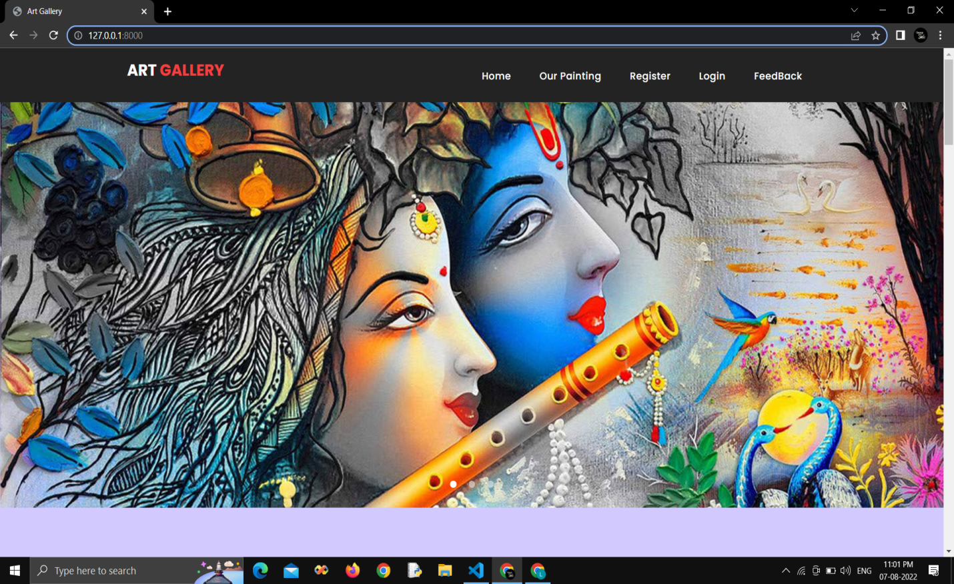

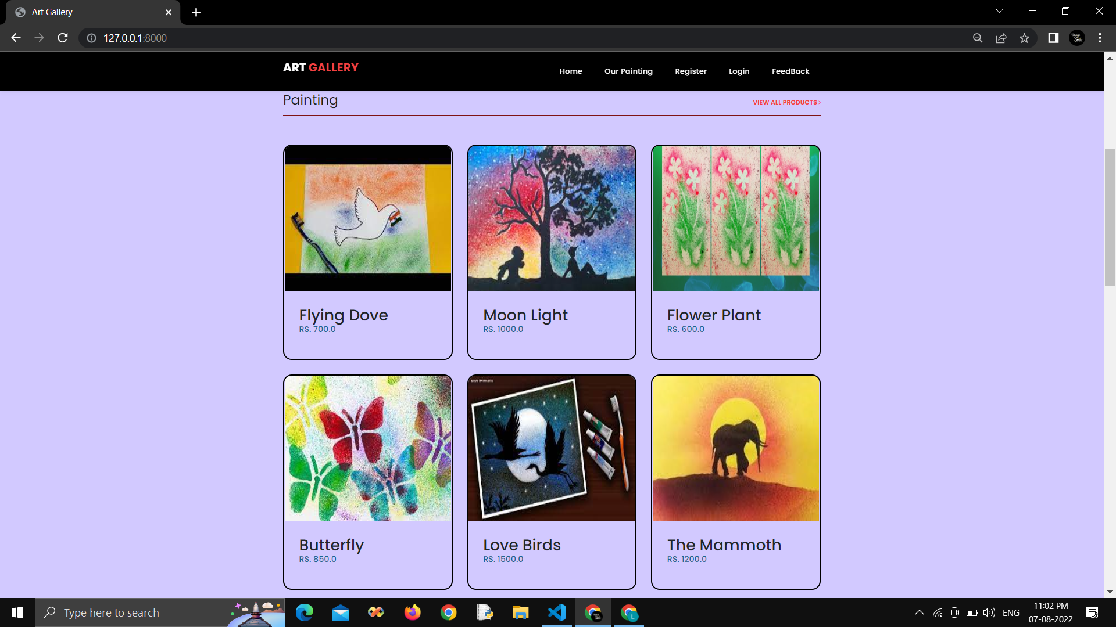

**Registration page:**

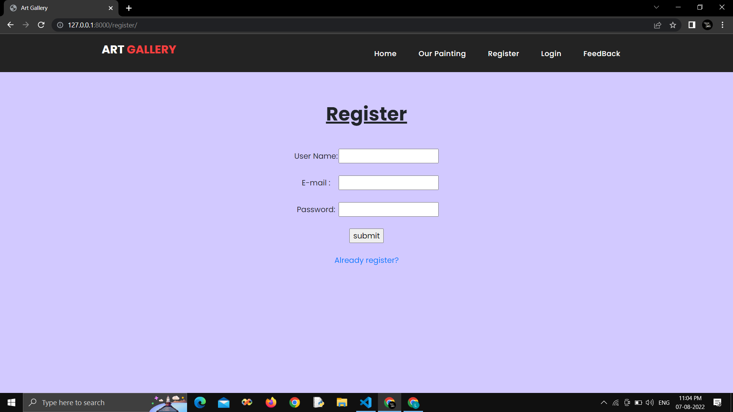

**Login page:**

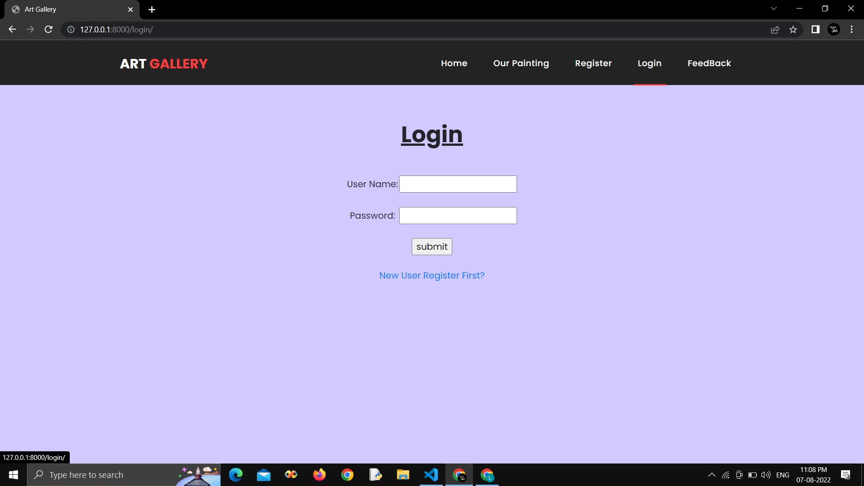

**After Login Home page:**

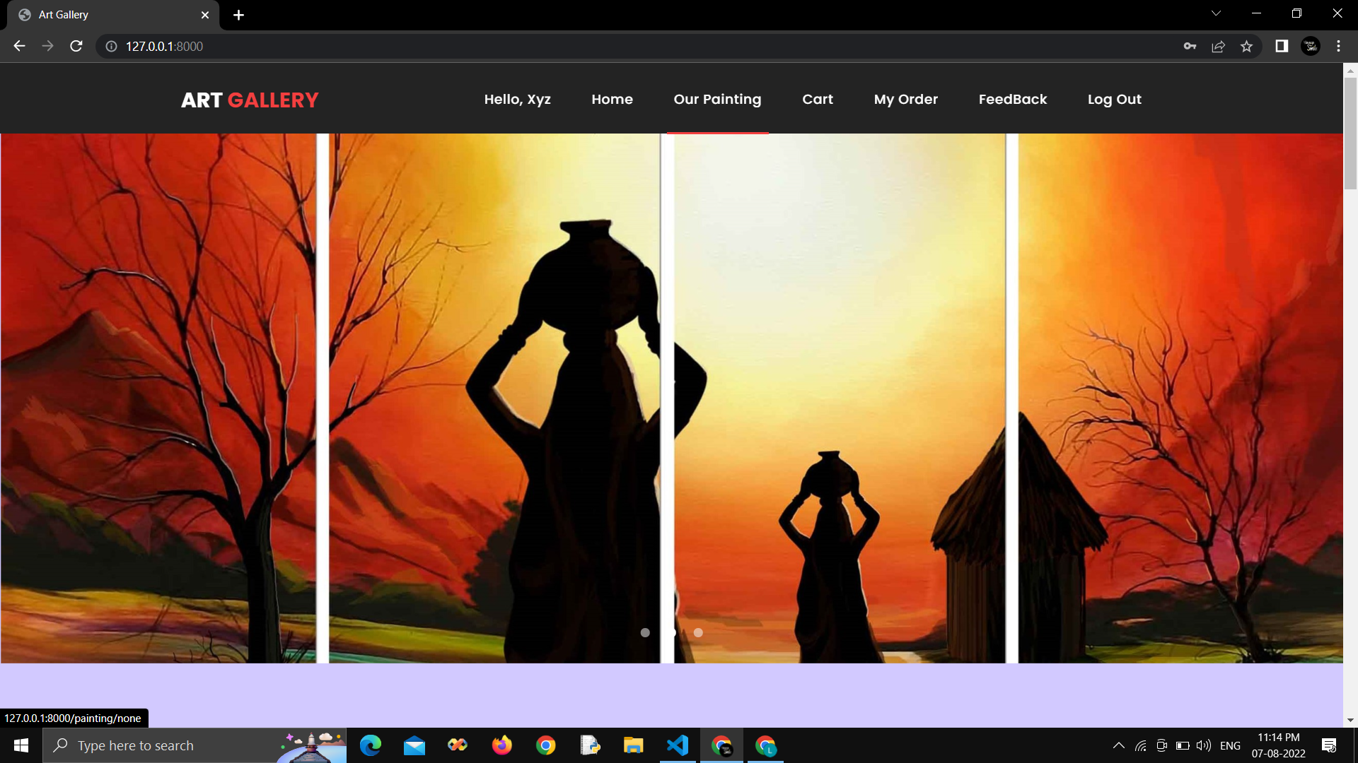**Painting Page:**

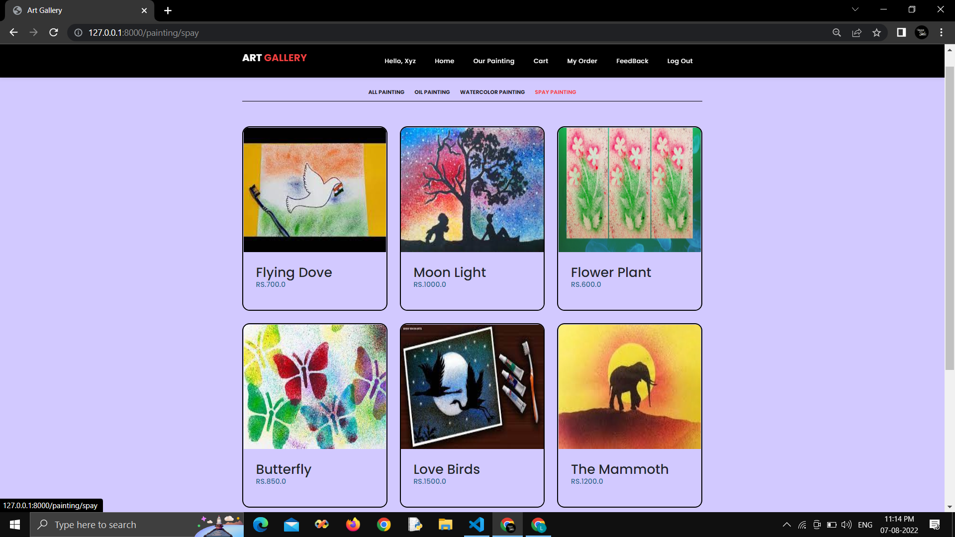

**Painting Detail Page:**

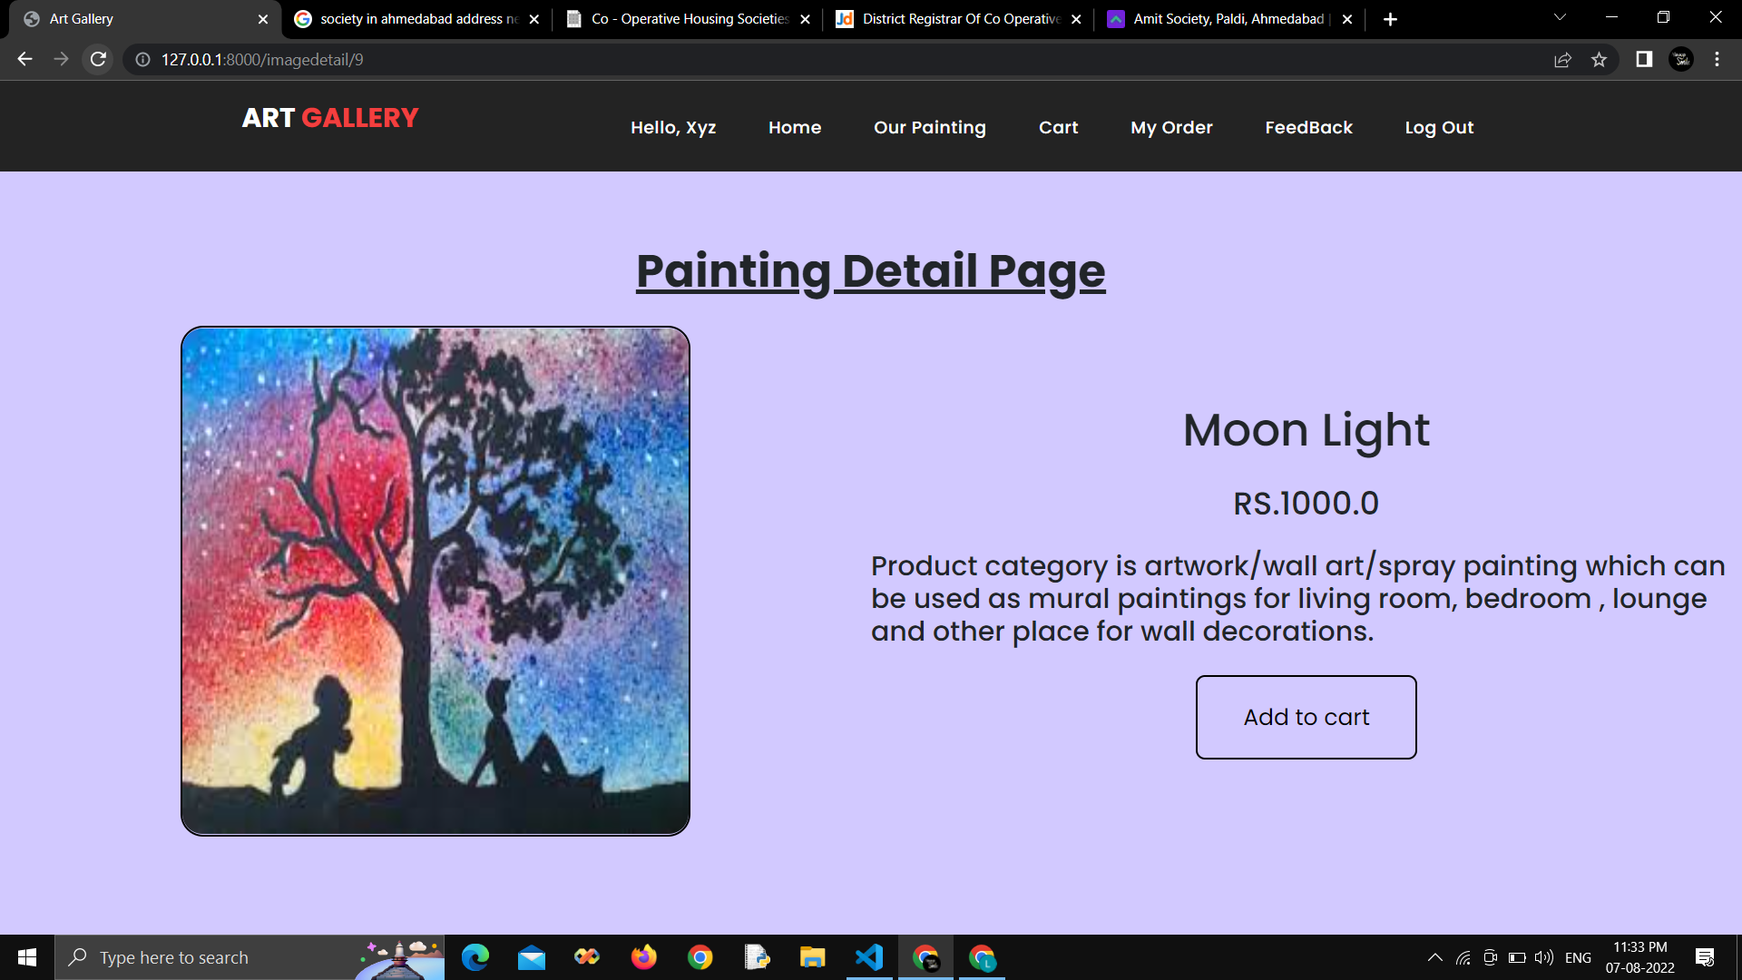

**Cart Page:**

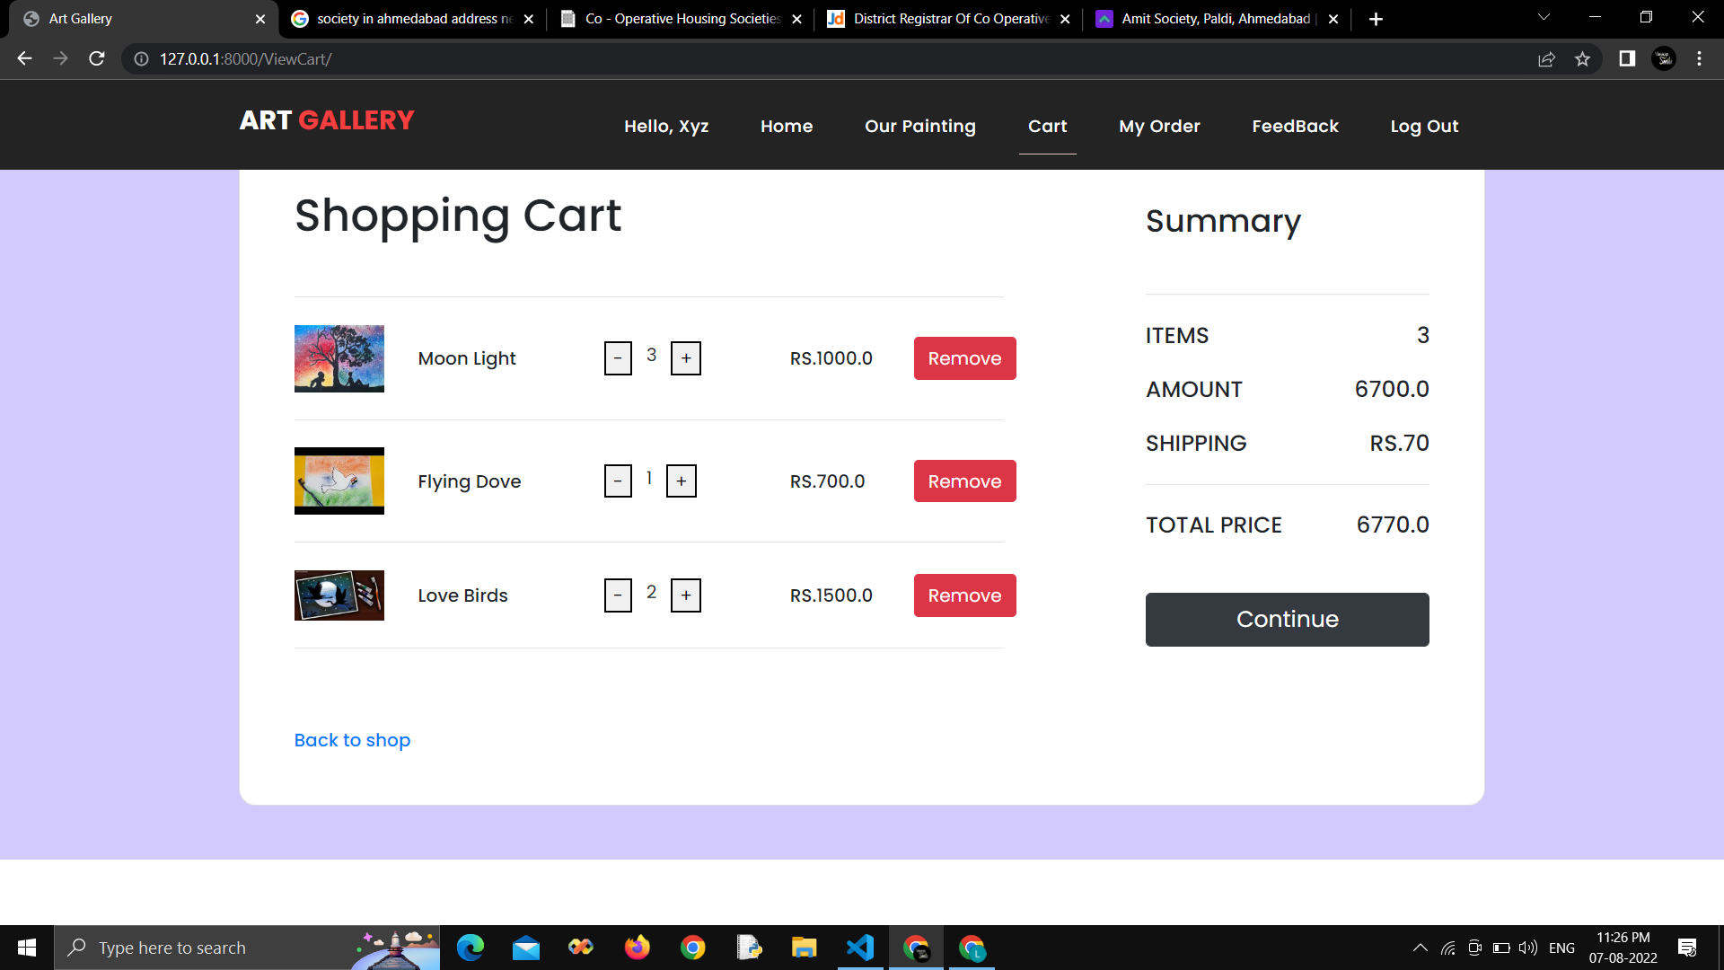

**Customer DetailPage**

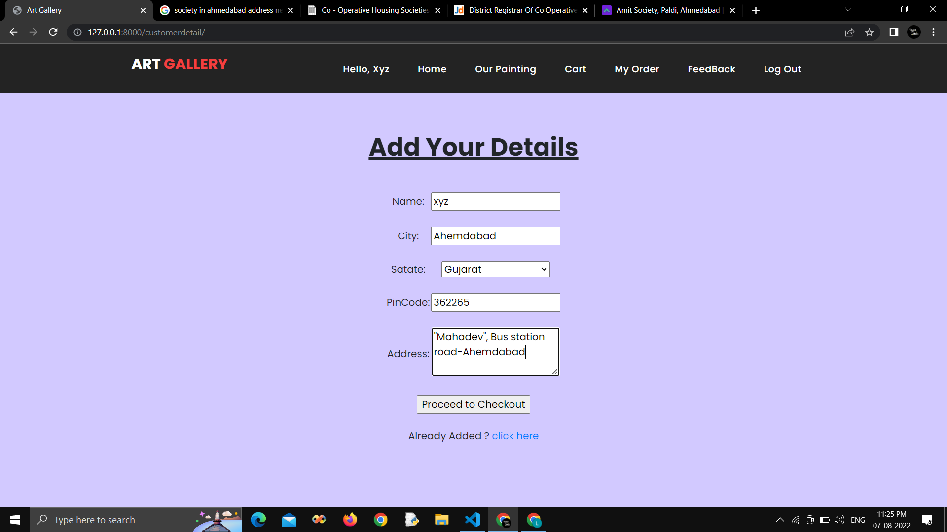

**Order DetailPage**

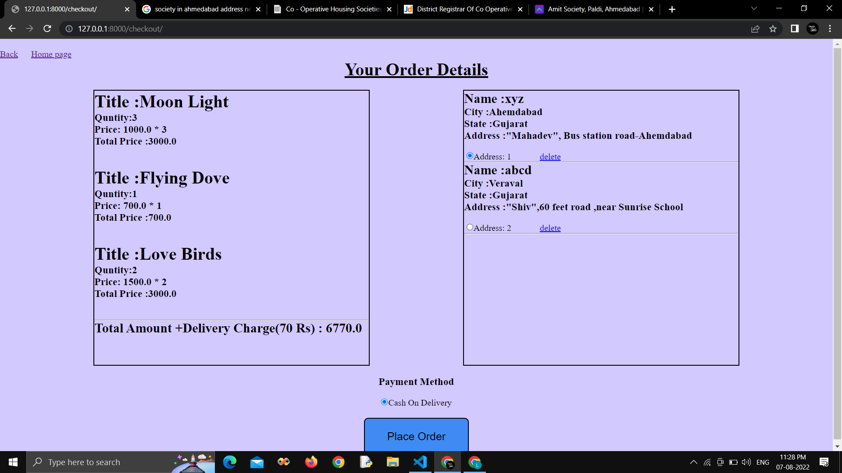

**MyOrder Page**

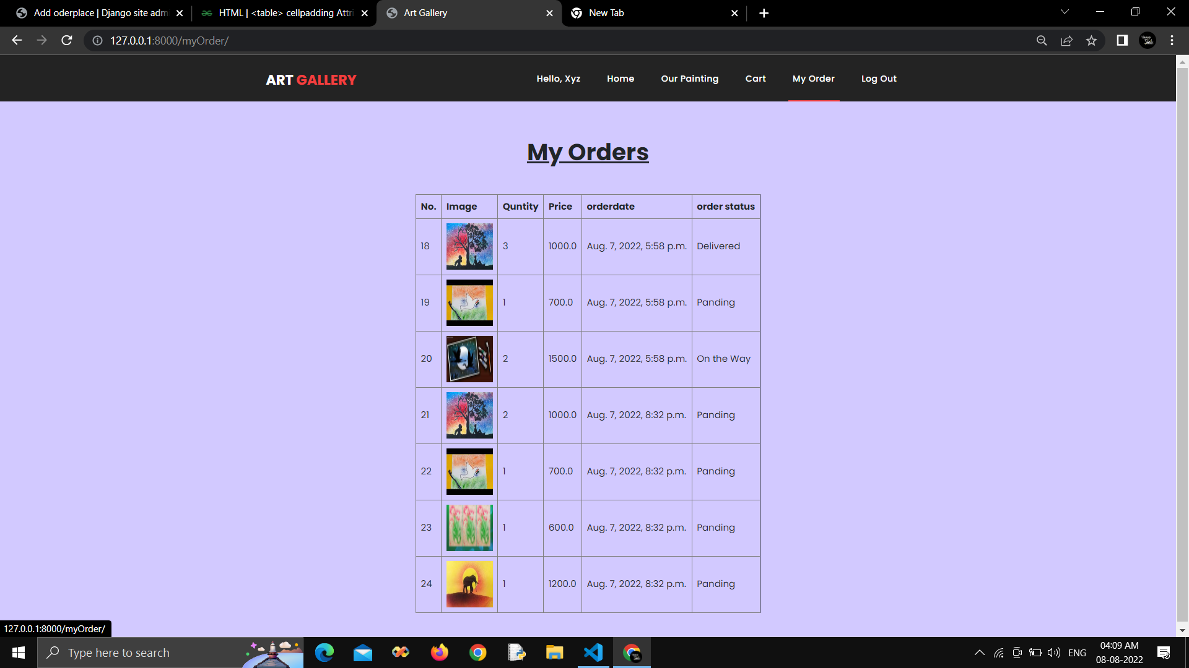

**Feedback page**

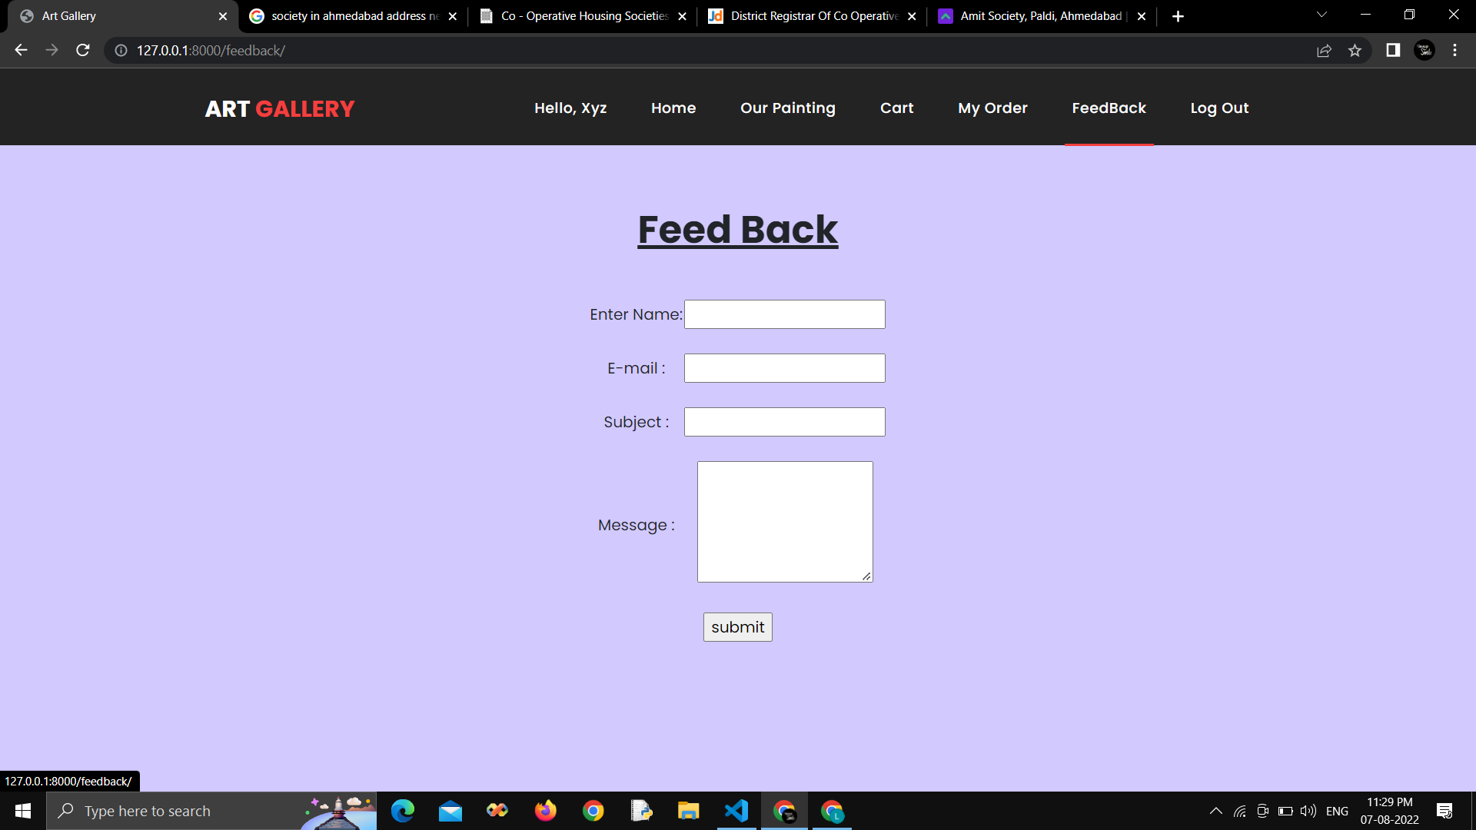

19. BIBLIOGRAPHY

To develop this “Web application of online paintings selling” we used Python(Django) as front end and back. We take some knowledge towards automation system from some books and web references that are given below.

* [www.javatpoint.com](http://www.javatpoint.com)
* [www.Django.com](http://www.tutorialspoint.com)
* [www.tutorialspoint.com](http://www.tutorialspoint.com)
* [www.w3schools.com](http://www.w3schools.com)

***Developed By***

***Lajvanti Sonaiya***

***Kajal Selarka***

***Upasana Joshi***